

Faculty of Engineering (Degree)
Semester – 1
Subject Name – Programming for Problem Solving
Subject Code – BE200104
Faculty Name – Ashwini Walake
Unit - 8: Structures and Unions

C Structures
In C, a structure is a user-defined data type that can be used to group items of possibly different types into a single type.
The struct keyword is used to define a structure. The items in the structure are called its members and they can be of any valid data type.
Applications of structures involve creating data structures Linked List and Tree. Structures in C are also used to represent real world objects in a software like Students and Faculty in a college management software.
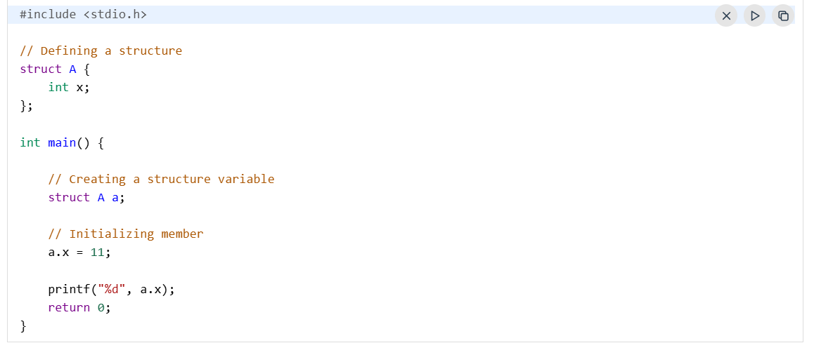
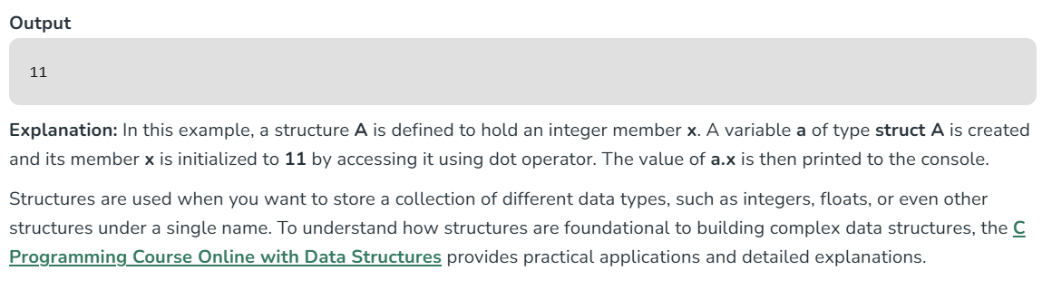
Syntax of Structure
There are two steps of creating a structure in C:
- Structure Definition
- Creating Structure Variables
Structure Definition
A structure is defined using the struct keyword followed by the structure name and its members. It is also called a structure template or structure prototype, and no memory is allocated to the structure in the declaration.
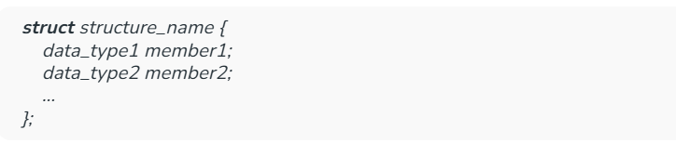
structure_name: Name of the structure.
member1, member2, ...: Name of the members.
data_type1, data_type2, ...: Type of the members.
Be careful not to forget the semicolon at the end.

Creating Structure Variable
After structure definition, we have to create variable of that structure to use it. It is similar to the any other type of variable declaration:
struct structure_name var;
We can also declare structure variables with structure definition.
struct structure_name {
...
}var1, var2....;
Basic Operations of Structure
Following are the basic operations commonly used on structures:
1. Access Structure Members
To access or modify members of a structure, we use the ( . ) dot operator. This is applicable when we are using structure variables directly.

In the case where we have a pointer to the structure, we can also use the arrow operator to access the members.

2. Initialize Structure Members
Structure members cannot be initialized with the declaration. For example, the following C program fails in the compilation.

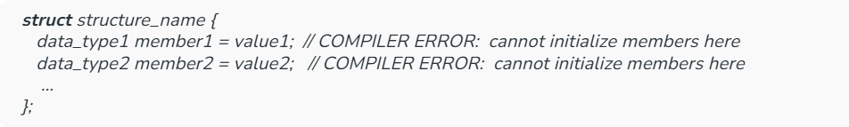
The reason for the above error is simple. When a datatype is declared, no memory is allocated for it. Memory is allocated only when variables are created. So there is no space to store the value assigned.
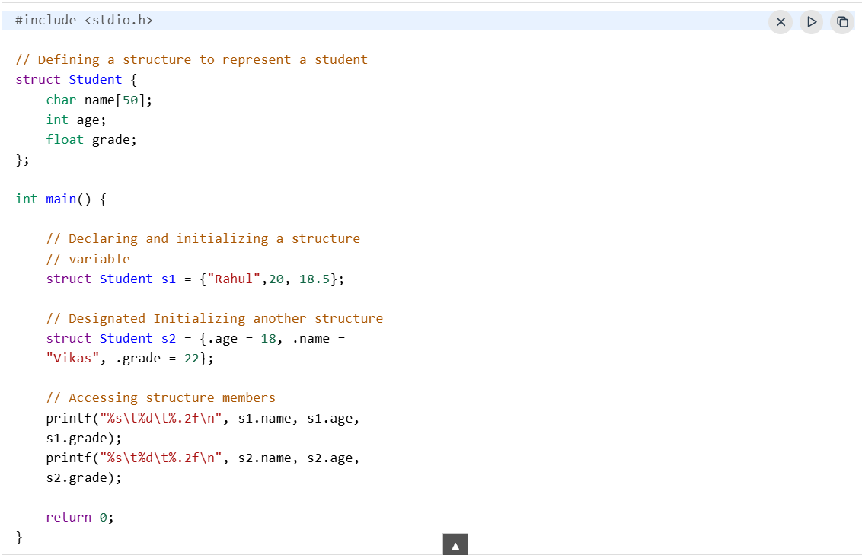
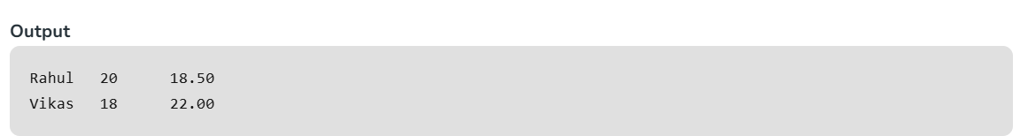
We can initialize structure members in 4 ways which are as follows:
Default Initialization
By default, structure members are not automatically initialized to 0 or NULL. Uninitialized structure members will contain garbage values. However, when a structure variable is declared with an initializer, all members not explicitly initialized are zero-initialized.
Initialization using Assignment Operator

Note: We cannot initialize the arrays or strings using assignment operator after variable declaration.
Initialization using Initializer List
3. Copy Structure
Copying structure is simple as copying any other variables. For example, s1 is copied into s2 using assignment operator.
s2 = s1;
But this method only creates a shallow copy of s1 i.e. if the structure s1 have some dynamic resources allocated by malloc, and it contains pointer to that resource, then only the pointer will be copied to s2. If the dynamic resource is also needed, then it has to be copied manually (deep copy).
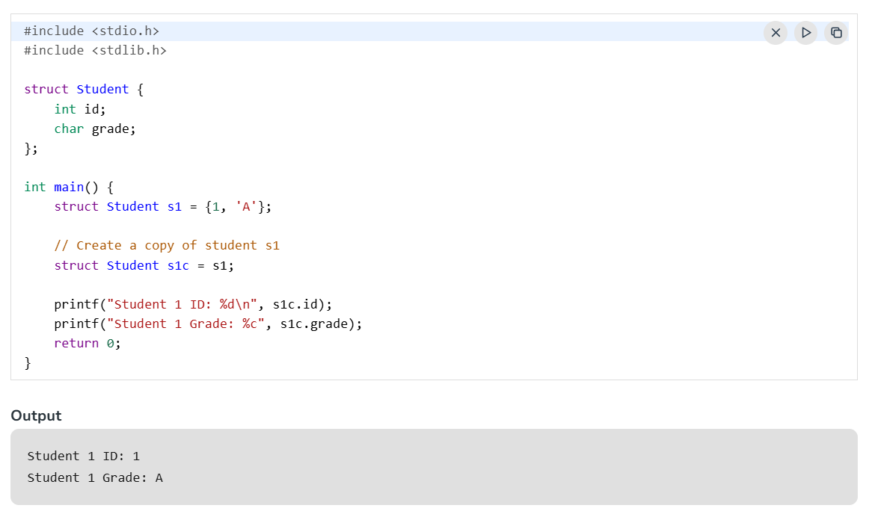
4. Passing Structure to Functions
Structure can be passed to a function in the same way as normal variables. Though, it is recommended to pass it as a pointer to avoid copying a large amount of data.
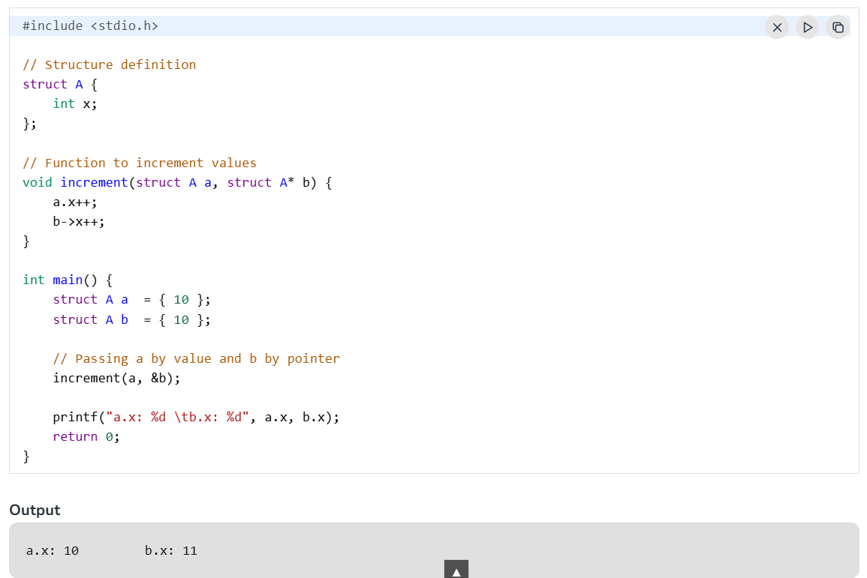
5. typedef for Structures
The typedef keyword is used to define an alias for the already existing datatype. In structures, we have to use the struct keyword along with the structure name to define the variables. Sometimes, this increases the length and complexity of the code. We can use the typedef to define some new shorter name for the structure.
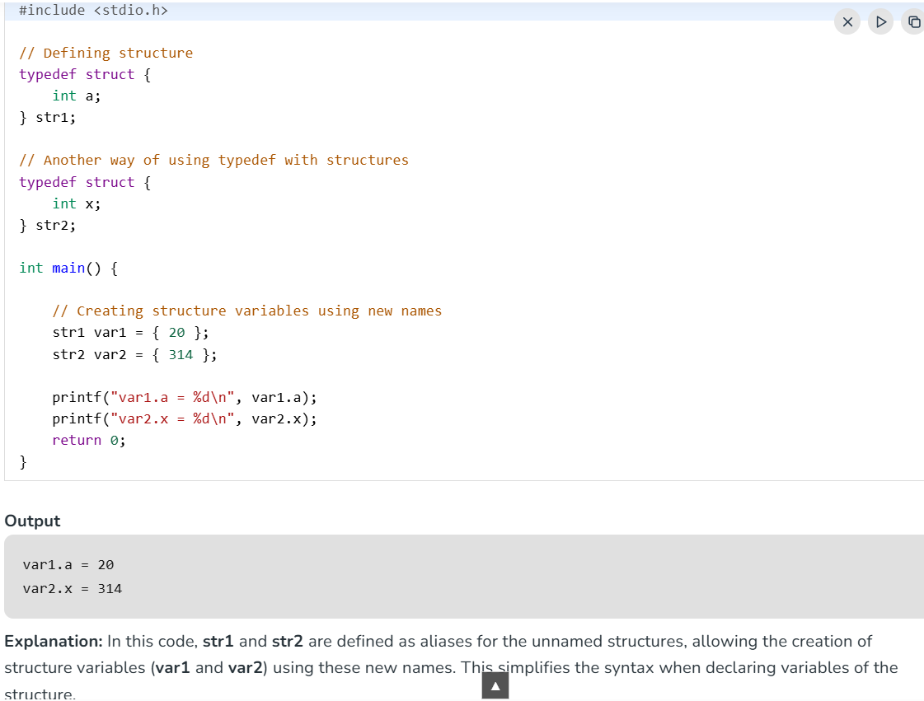
Nested Structures
In C, a nested structure refers to a structure that contains another structure as one of its members. This allows you to create more complex data types by grouping multiple structures together, which is useful when dealing with related data that needs to be grouped within a larger structure.
There are two ways in which we can nest one structure into another:
- Embedded Structure Nesting: The structure being nested is also declared inside the parent structure.
- Separate Structure Nesting: Two structures are declared separately and then the member structure is nested inside the parent structure.
Accessing Nested Members
We can access nested Members by using the same ( . ) dot operator two times as shown:
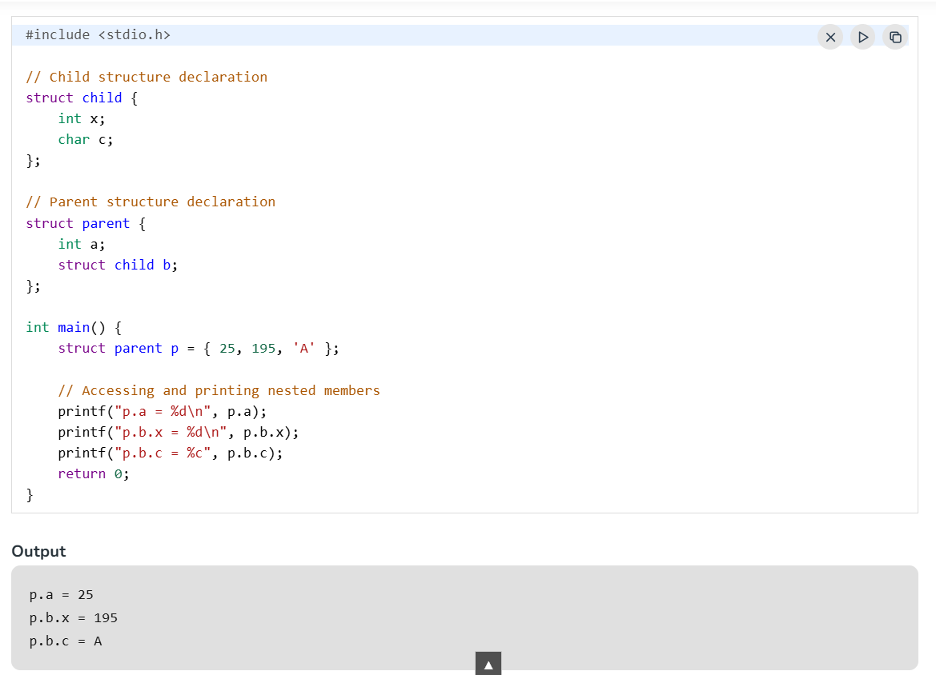
Explanation: In this code, the structure parent contains another structure child as a member. The parent structure is then initialized with values, including the values for the child structure's members.

Uses of Structure in C
C structures are used for the following:
- The structure can be used to define the custom data types that can be used to create some complex data types such as dates, time, complex numbers, etc. which are not present in the language.
- It can also be used in data organization where a large amount of data can be stored in different fields.
- Structures are used to create data structures such as trees, linked lists, etc.
- They can also be used for returning multiple values from a function.
Array of Structures in C
An array of structures is simply an array where each element is a structure. It allows you to store several structures of the same type in a single array.
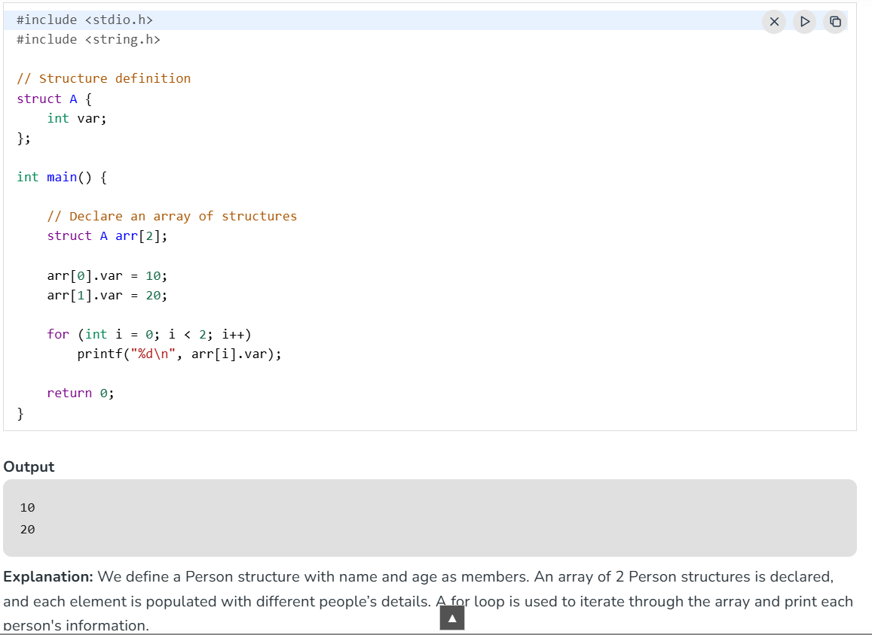
Array of Structure Declaration
Once you have already defined structure, the array of structure can be defined in a similar way as any other variable.
Need for Array of Structures
Suppose we have 50 employees, and we need to store the data of 50 employees. So for that, we need to define 50 variables of struct Employee type and store the data within that. However, declaring and handling the 50 variables is not an easy task. Let's imagine a bigger scenario, like 1000 employees.
So, if we declare the variable this way, it's not possible to handle this.
For that, we can define an array whose data type will be struct Employee soo that will be easily manageable.
- Arrays of structures allow you to group related data together and handle multiple instances of that data more efficiently.
- It is particularly useful when you want to manage large datasets (such as a list of employees, students, or products) where each element has a consistent structure.
Basic Operations on Array of Structures
Following are the basic operations on array of structures:
Initialization
A structure can be initialized using initializer list and so can be the array. Therefore, we can initialize the array of structures using nested initializer list:
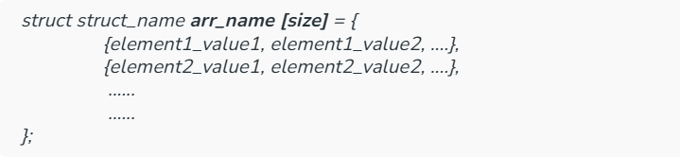
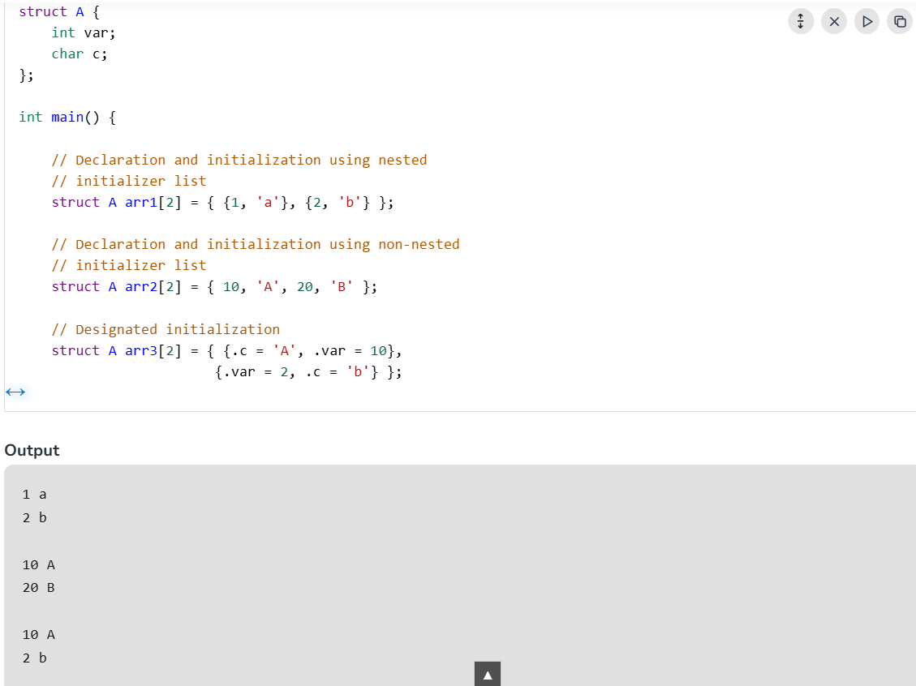
Example of Array of Structure
The below code demonstrates the application of array of structure inside a C program:
Store Student Information
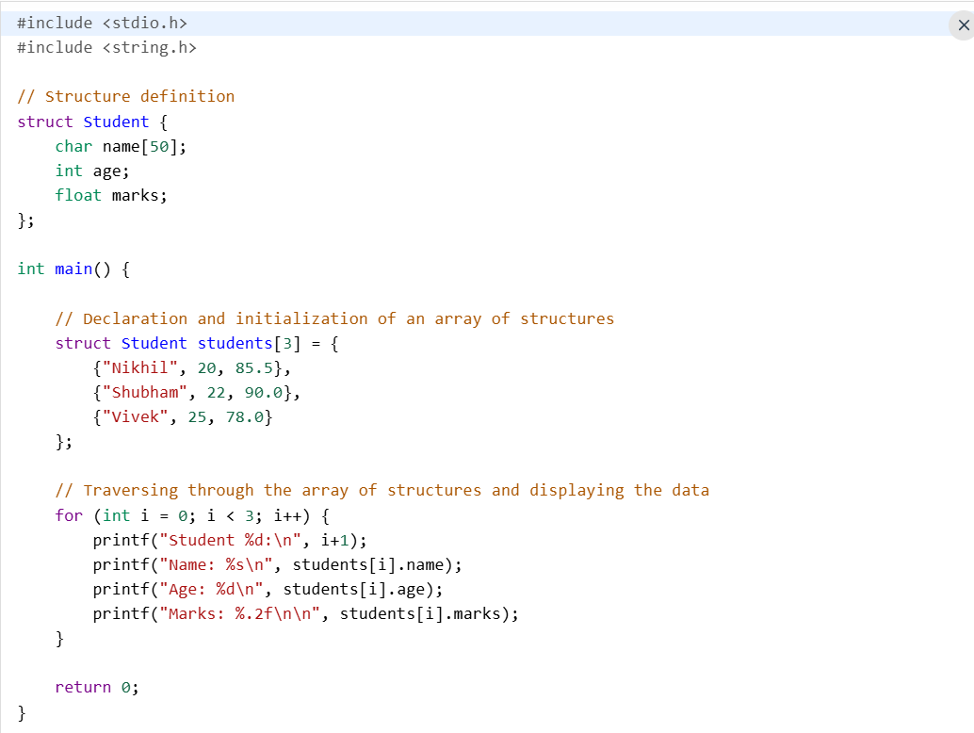
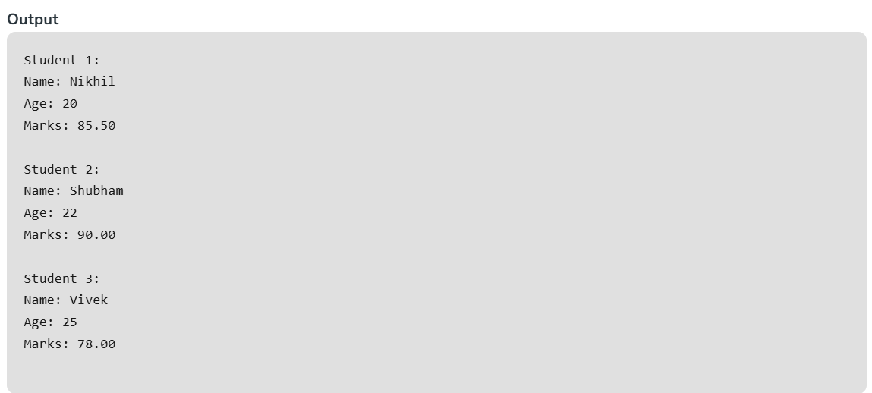
How to Return Struct from a Function
We know that a function in C can return a value of any type. In this example, the area() function is defined to return a struct variable.

Example
Inside the main() fuction, the inputs for the length and the breadth are passed to the area() function. Inside the area() function, the area is computed and a struct variable is populated and returned to the main() function, where its elements are displayed.
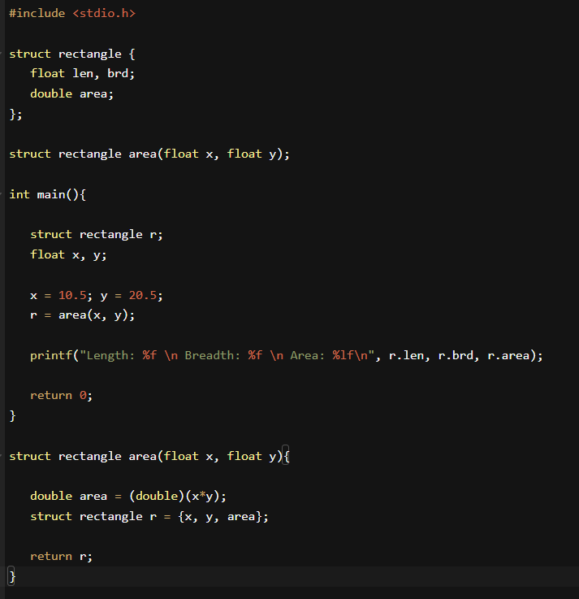
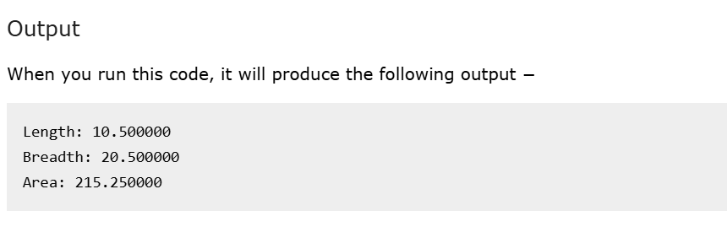
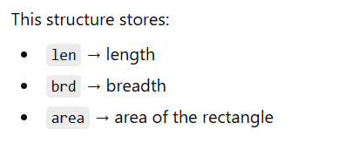
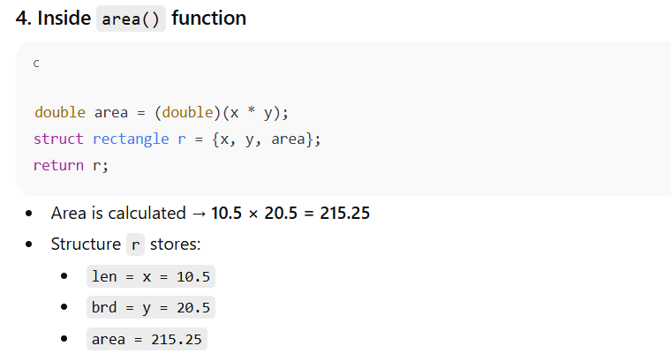
C Unions
In C, union is a user-defined data type that can contain elements of the different data types just like structure. But unlike structures, all the members in the C union are stored in the same memory location. Due to this, only one member can store data at the given point in time.
The value of a union variable can be accessed using the dot (.) operator. A value can be assigned to the union variable using the assignment operator (=).
In a union, all the variables share the same memory, so only one variable can store a value at a time.
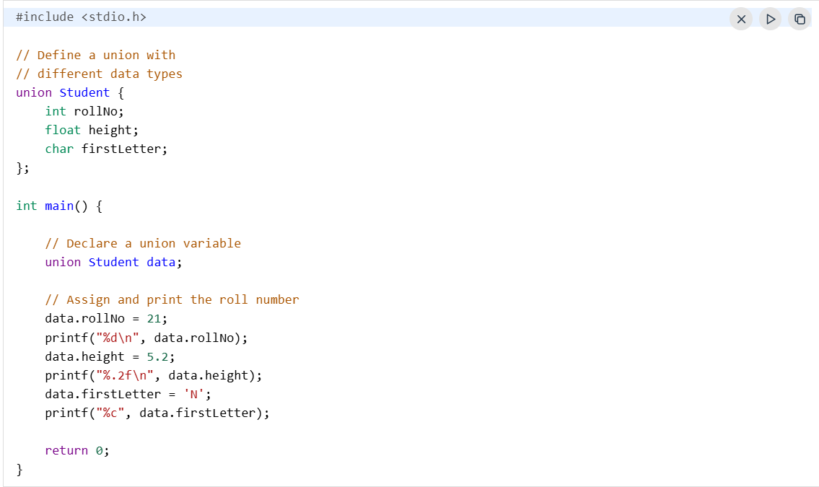
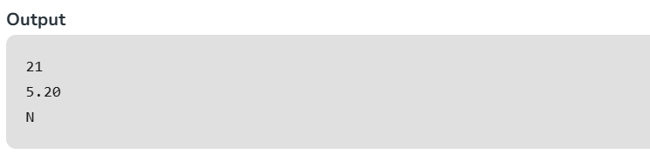
Union Declaration
A union is declared similarly to a structure. Provide the name of the union and define its member variables:
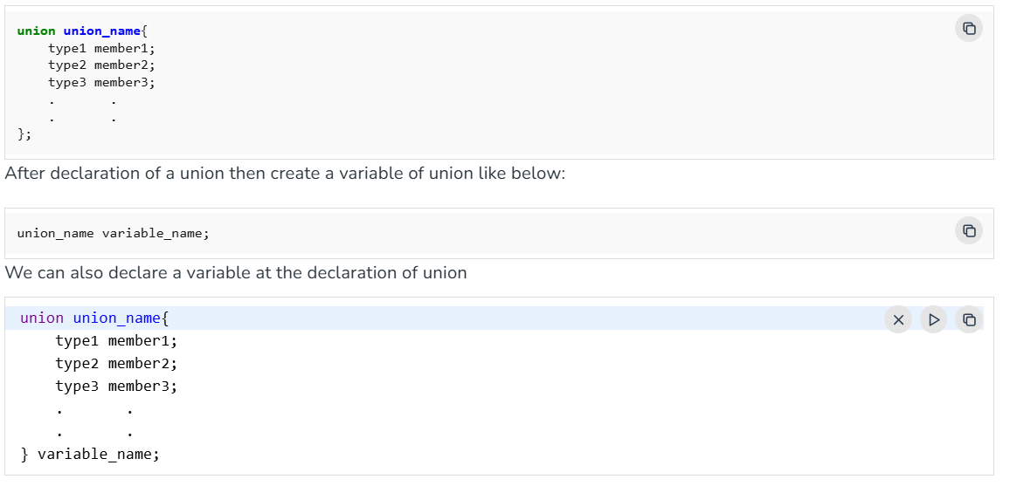
Size of Union
The size of the union will always be equal to the size of the largest member of the union. All the less-sized elements can store the data in the same space without any overflow. Let's take a look at the code example:
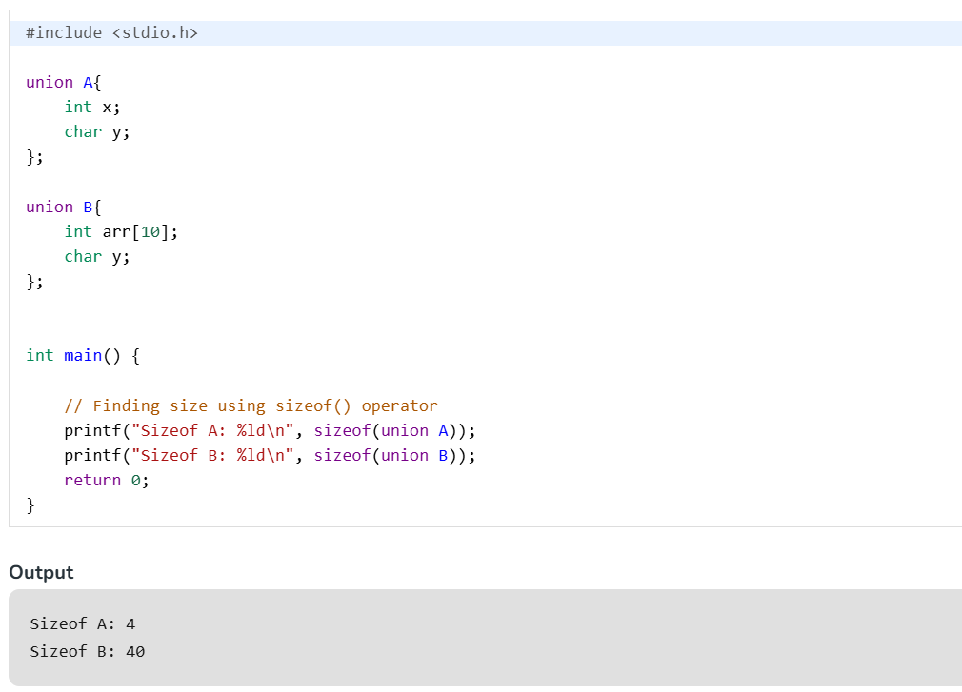
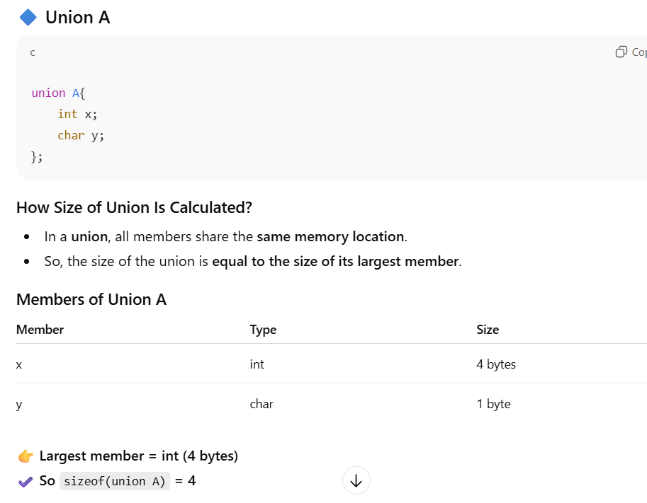
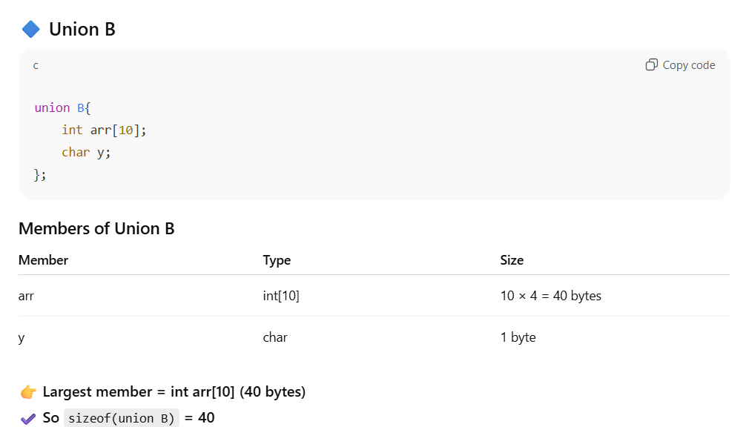

Applications of Union in C
- Used for memory efficiency, particularly in embedded systems or situations where memory is a critical resource. By having different data types share the same memory, they reduce the overall memory footprint compared to a structure.
- Embedded Systems (Sensors & Hardware Data)
- Network Programming (Data Packets)
- Memory Optimization in Mobile/IoT Devices
- Device Drivers

Difference Between Structures and Unions
The primary difference between a structure and a union lies in memory allocation and data storage. A structure allocates separate, unique memory locations for each of its members, allowing you to store and access multiple values simultaneously. A union.
Direct Comparison
Feature | Structure (struct) | Union (union)
Keyword | Used with struct. | Used with union.
Memory Space | Each member gets its own unique memory slot. | All members share the exact same memory space.
Total Size | Equal to or greater than the sum of all members (plus compiler padding). | Exactly equal to the size of its largest member.
Data Access | You can access any or all members at the same time. | You can only access one active member at a time.
Value Alteration | Changing one member does not affect the others. | Changing one member overwrites and corrupts the others.
Initialization | Multiple or all members can be initialized at once. | Only the first defined member can be initialized.

